**Windows 10 UWP – Hands on Lab**

**Lab 2:**

**Note**: The demo app created for this lab uses Visual Studio 2015 with the latest Windows Tools SDK version 10240. To help with our coding efforts with the boiler code and page navigation we use a UWP app extension called Template 10.

1. Select the “Models” folder and bring up the popup menu and select “Add->Existing Item”. This will bring up Windows Explorer. Navigate to the folder (i.e. C:\Projects\Windows10UWP-HandsOnLab\Lab2\Completed\HowToBBQ.Win10\HowToBBQ.Win10\Models) where the lab files have been downloaded. Add the following file located in the “Models” folder (BBQRecipe.cs)

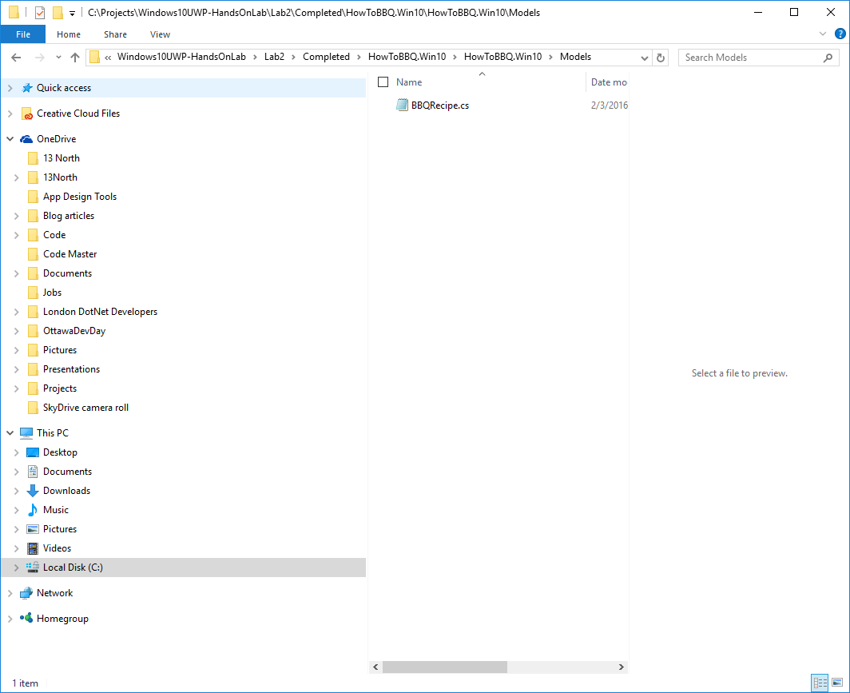

1. Select the “Services” folder and create a new folder called RecipeServices. Bring up the popup menu and select “Add->Existing Item”. This will bring up Windows Explorer. Navigate to the folder (i.e. C:\Projects\Windows10UWP-HandsOnLab\Lab2\Completed\HowToBBQ.Win10\HowToBBQ.Win10\Services\RecipeServices) where the lab files have been downloaded. Add the following files located in the “RecipeServices” folder (IRecipeServices.cs, RecipeServices.cs)

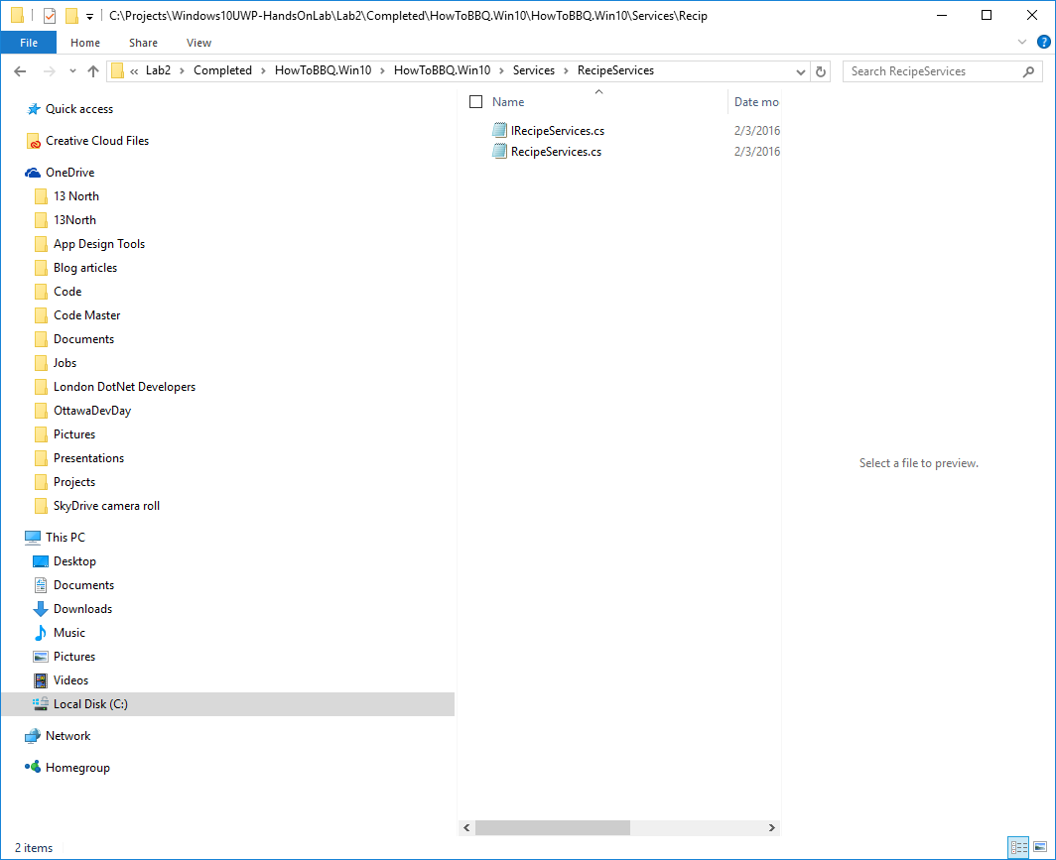

1. Select the “Assets” folder and bring up the popup menu and select “Add->Existing Item”. This will bring up Windows Explorer. Navigate to the folder (i.e. C:\Projects\Windows10UWP-HandsOnLab\Lab2\Completed\HowToBBQ.Win10\HowToBBQ.Win10\Assets) where the lab files have been downloaded. Add the following files located in the “Assets” folder (all the picture files *.png *.jpg ). Make sure to include these into the solution using VS2015.

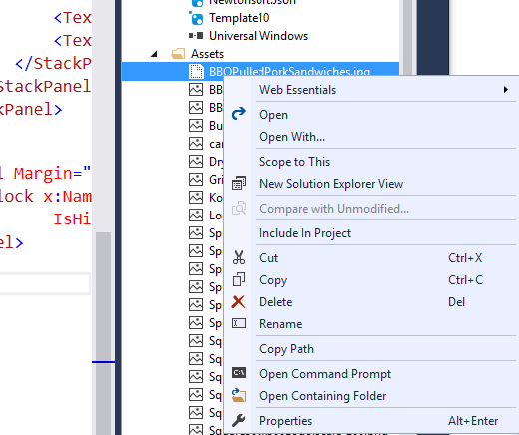

1. For the next step we will replace the mainpage and detailpage viewmodels for our application. Under the ViewModels folder within VS2015 delete DetailPageViewModel.cs and MainPageViewModel.cs.
2. Like before we will add the DetailPageViewModel.cs and MainPageViewModel.cs. Bring up the popup menu and select “Add->Existing Item”. This will bring up Windows Explorer. Navigate to the folder (i.e. C:\Projects\Windows10UWP-HandsOnLab\Lab2\Completed\HowToBBQ.Win10\HowToBBQ.Win10\ViewModels) where the lab files have been downloaded. Add the following files located in the “ViewModels” folder (DetailPageViewModel.cs and MainPageViewModel.cs)
3. Open the App.xaml.cs and add the following code starting on line 16. We are setting up data service and in memory holding area for storing our recipes. In a production application this would be doing using web api or SQLite database to manage our data.

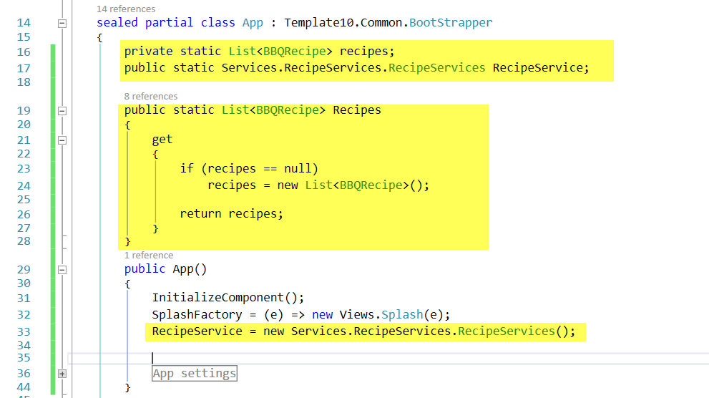

private static List<BBQRecipe> recipes;

     public static Services.RecipeServices.RecipeServices RecipeService;

     public static List<BBQRecipe> Recipes

     {

         get

         {

             if (recipes == null)

                 recipes = new List<BBQRecipe>();

             return recipes;

         }

     }

     public App()

     {

         …

         RecipeService = new Services.RecipeServices.RecipeServices();

}

1. In the App.xaml.cs file, add the following code on to the top of the file.

using HowToBBQ.Win10.Services.SettingsServices;

using System.Collections.Generic;

using HowToBBQ.Win10.Models;

1. In the file Mainpage.xaml.cs make sure to disable the navigation caching. This will allow for proper back button navigation from the details page to the main page.

public MainPage()

 {

     InitializeComponent();

     NavigationCacheMode = NavigationCacheMode.Disabled;

 }

1. In the file MainPage.xaml and add the following lines of xaml code and replace the lines after the page content comment tags. So in this step we are remove the default template place holder code.

<!--  page content  -->

        <GridView x:Name="RecipesGridView" Grid.Row="1" ItemsSource="{Binding Recipes}" SelectionMode="Single" IsItemClickEnabled="True">

            <Interactivity:Interaction.Behaviors>

                <Core:EventTriggerBehavior EventName="ItemClick">

                    <Core:CallMethodAction MethodName="GotoDetailsPage"

                    TargetObject="{Binding Mode=OneWay}" />

                </Core:EventTriggerBehavior>

            </Interactivity:Interaction.Behaviors>

            <GridView.ItemTemplate>

                <DataTemplate>

                    <Grid>

                        <Image Source="{Binding ImagePath}" Stretch="UniformToFill" Width="600"/>

                        <Border Background="#99000000" VerticalAlignment="Bottom">

                            <TextBlock Text="{Binding Name}"

                           FontSize="30" VerticalAlignment="Center"/>

                        </Border>

                    </Grid>

                </DataTemplate>

            </GridView.ItemTemplate>

        </GridView>

1. Open the file BBQRecipe.xaml and add the following lines of xaml code and replace the lines after the page content comment tags. So in this step we are remove the default template place holder code.

<Grid Grid.Row="1" x:Name="BBQRecipeGridView" Grid.RowSpan="2" Margin="46,0,50,0" DataContext="{Binding Recipe}">

            <StackPanel Orientation="Vertical" d:LayoutOverrides="Height">

                <StackPanel x:Name="ImageStackPanel"  Orientation="Vertical">

                    <Image x:Name="BBQImage" Source="{Binding ImageUri}" Stretch="UniformToFill" />

                </StackPanel>

                <StackPanel x:Name="DetailstackPanel" Orientation="Vertical" HorizontalAlignment="Left" d:LayoutOverrides="LeftPosition, RightPosition">

                    <StackPanel Margin="0,20,20,10">

                        <TextBlock Text="ImageUri" FontSize="14"/>

                        <TextBox  Text="{Binding ImagePath}"/>

                    </StackPanel>

                    <StackPanel Margin="0,20,20,10">

                        <TextBlock Text="Name" FontSize="14"/>

                        <TextBox x:Name="TextBoxTitle" Text="{Binding Name, Mode=TwoWay}"/>

                    </StackPanel>

                    <StackPanel Margin="0,0,20,10">

                        <TextBlock Text="Prep Time" FontSize="14"/>

                        <TextBox Text="{Binding PrepTime, Mode=TwoWay}"/>

                    </StackPanel>

                    <StackPanel Margin="0,0,20,10">

                        <TextBlock Text="Total Time" FontSize="14"/>

                        <TextBox Text="{Binding TotalTime, Mode=TwoWay}"/>

                    </StackPanel>

                    <StackPanel Margin="0,0,20,10">

                        <TextBlock Text="Serves" FontSize="14"/>

                        <TextBox Text="{Binding Serves, Mode=TwoWay}"/>

                    </StackPanel>

                    <StackPanel Margin="0,0,20,10">

                        <TextBlock Text="Ingredients" FontSize="14"/>

                        <TextBox Text="{Binding Ingredients, Mode=TwoWay}"/>

                    </StackPanel>

                    <StackPanel Margin="0,0,20,10">

                        <TextBlock Text="Directions" FontSize="14"/>

                        <TextBox Text="{Binding Directions, Mode=TwoWay}" Height="150" TextWrapping="Wrap"/>

                    </StackPanel>

                </StackPanel>

            </StackPanel>

        </Grid>